INVESTIGATION

IDEAS

Education Statistics-
Was interested in average success in the LC relative to their subjects, Possibly the link with mental health and stress, didn’t go through due to lack of interest and lack of data for Irish LC

Stars and their properties-
Big interest of mine and one of my first ideas, Making predictions would be easy as many formulas and equations exist to make predictions already, unfortunately most data was either too basic or too complicated, Most datasets failed to give useful data.

Exoplanets-
My final idea became my chosen idea, very strong interest and very closely related to my desired college course, many values were influenced by each other and easy relations could be found and useful predictions made, most data would be recent due to the data from advancements in modern technology

Chosen Idea- Exoplanets
My goal is to produce an information system that shows the pattern and relation of variables between different exoplanet types providing general analysis and information about these celestial bodies.
Particularly I find the relation between the exoplanet type and its radius length to be interesting and useful information to analyse.
Intended for researchers and astronomy/astrophysics enthusiasts to learn more about the trends seen in these extrasolar planets and assist in future predictions.
This heavily relates to my interests as I’ve been intending to go into astrophysics as a college course and career path.

Example Information Systems
https://exoplanetarchive.ipac.caltech.edu/ - Very good example of a related information system
Pros( interactive, lots of info ) Cons( too much info, tools not very well explained )
https://science.nasa.gov/exoplanets/exoplanet-catalog/ - Similar but with more flaws
Pros( information accessible, good presentation ) Cons( low interactivity, lacking deep analysis )
The ideal would be somewhere between these two.

Potential Datasets
https://www.kaggle.com/datasets/jsonali2003/stellar-classification-dataset
- Had useable information but too little rows and columns and many useless values
https://www.kaggle.com/datasets/jsonali2003/stellar-classification-dataset
- A lot more data but overly complex and difficult to use and interpret
https://www.kaggle.com/datasets/waqi786/stars-dataset/data
- Seemed ideal with good info and size but contains so many duplicates each with their own contradicting data. Out of over a 1000 entries only 30 unique stars were present.
https://www.kaggle.com/datasets/franoisgeorgesjulien/nasa-exoplanet-archive-planetary-systems
- Ideal dataset as it focuses on an idea I was struggling to find useful data for (exoplanets). The database is very large and has many unique and varied elements. Contains missing info but the worst columns for missing info are not useful anyways.

Plan and Design

Design Plan
In order to meet the brief criteria I need to create 4 programs.
The first program should read data from my chosen exoplanet database and clean it. While some missing values will not impact any of my analysis others are required and some data will be cleared from the database for not having important values. I would then send the new cleaned data to a Firebase database.
The second program should read data from Firebase and analyse it. I would divide the database into the primary categories of exoplanets. Then I would get analytics of these exoplanet types. Finally I need to display graphs as representation of the graphs on my main website. The data used to make these graphs are sent to Firebase alongside the exoplanet type averages.
The third program will be my web-based interface focused on providing the public with information and displaying data visualisations.

Reading and Cleaning Flowchart
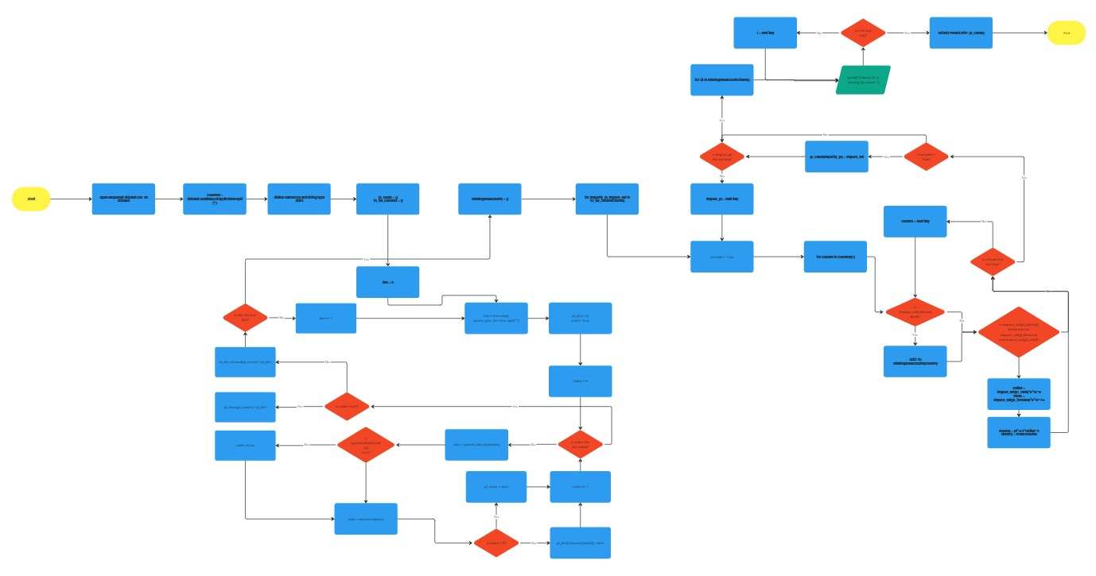

Analytics Flowchart
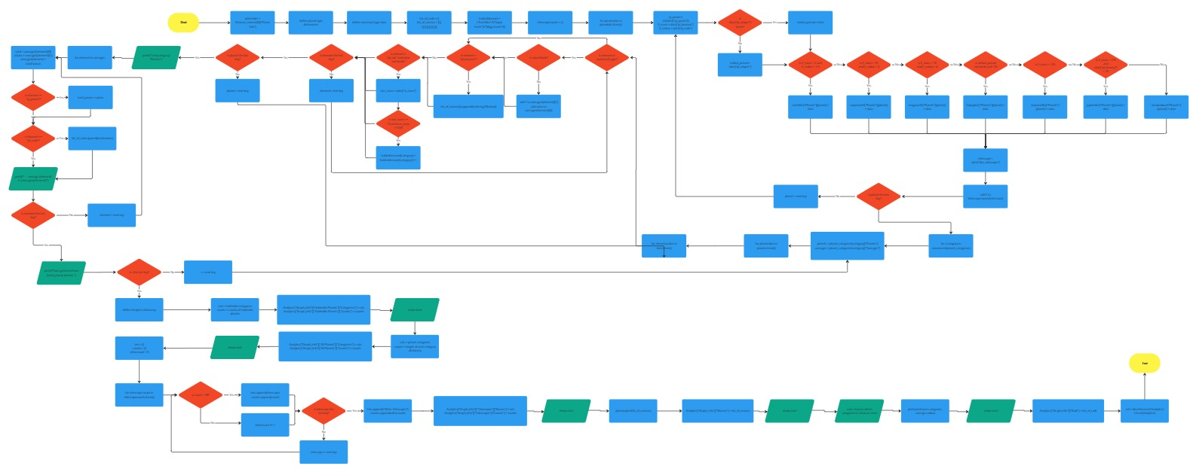

Webpage Flowchart

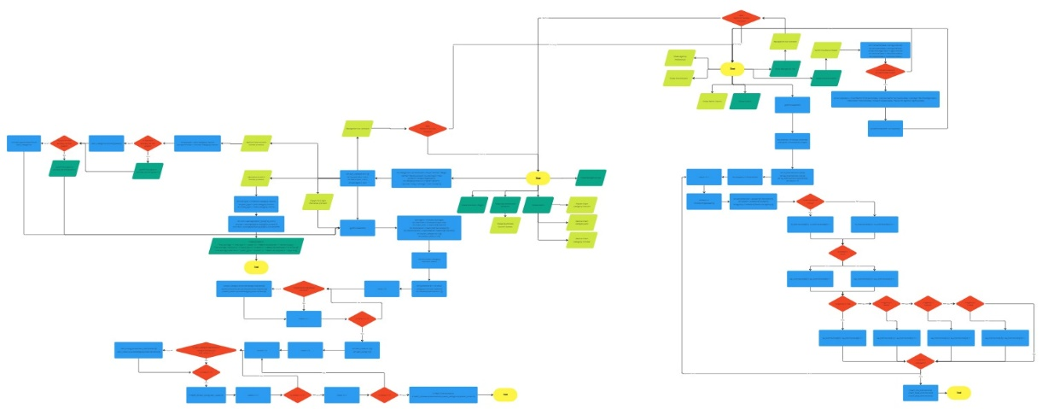

System Architecture Diagram
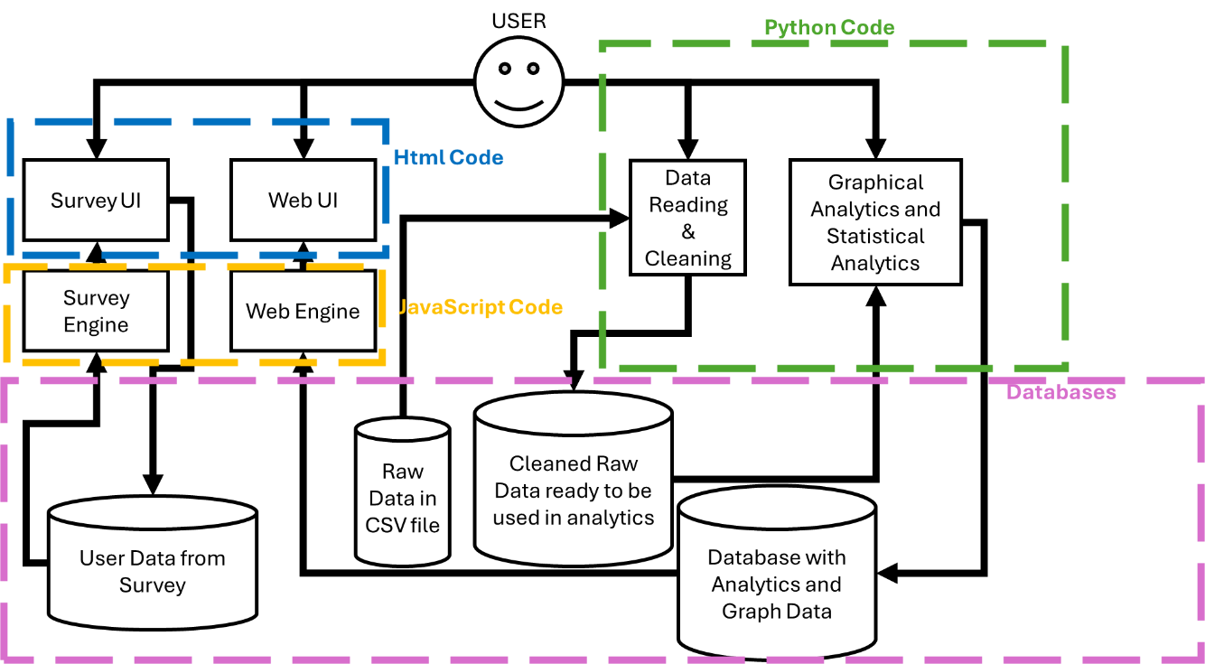

Wireframe Diagram

